MIDI Drum Sequencer (MDS) v 0.1

Quick Start Guide

1. Introduction

The MIDI Drum Sequencer (MDS) is designed to emulate hardware/software drum machines, allowing you to create and edit drum sequences (patterns) and combine them into entire songs. Patterns can be up to 32 steps long (longer patterns can be created by running two or more patterns in sequence). Patterns can be combined to run sequentially and/or in parallel, with virtually no limitation on the number of patterns involved or the complexity of their organization. Up to 8 instruments can be selected for each pattern, but if you need more than 8, you can have two patterns run concurrently (in parallel).

2. Installation Requirements

MDS was initially developed and tested under Pure Data v0.51.2 (64-bit) and Windows 7 SP 1 (64-bit). There's a good chance it will work on Linux and MacOS too, although it hasn't been tested.
Although it will probably run under earlier versions of Pure Data, there's no guarantee, and you may encounter problems if you're running a much older version of Pure Data or any of the required external libraries.
The following libraries, all of which can be installed using Deken (under the Help menu, click on “Find externals”):
- tof
- cyclone
- ggee
- zexy
- iemlib
- easyflow

3. Editing Songs

When you start up MDS (either by double-clicking on the file “Drum-Sequence.pd” or starting Pure Data and opening the file), the following window will open.

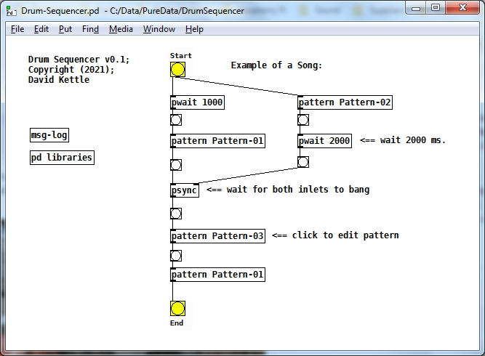
Although you can edit this file in Pure Data, it's recommended that you save a copy under a different name and make your changes to that file instead.
It's assumed that you have some familiarity with editing patches in Pure Data, although you don't need extensive knowledge. Patterns can be added or removed to your song by creating [pattern] objects, optionally specifying the file name as the first (and only) creation argument. For example, in the screen print above, there are 4 patterns: Pattern-01, Pattern-02, Pattern-03 and Pattern-01 (the same pattern can be used in more than one place).
The initial starting point of the song is indicated with a [song-start] object (which takes no creation arguments), and the end of the song is indicated with a [song-end] object (which likewise takes no arguments). Patterns are connected by drawing lines from the outlet of one pattern to the inlet of another. You may wish to place a [bang] between them to monitor the progress of your song, although this isn't required.
If you don't want a pattern to start immediately after the preceding pattern finishes, you can add a [pwait] object between them, specifying the wait time in milliseconds as the creation argument. For example, in the sample song above, Pattern-02 is followed by a wait or pause of 2000 ms (2 seconds).
If you have two patterns running in parallel, you can force them to synchronize by adding a [psync] object and connecting the outlets of both patterns to the two inlets of [psync]. For example, in the sample song above, Pattern-01 and Pattern-02 (followed by a wait of 2 sec.) are synchronized. In other words, the song will not continue until the [psync] object has received a [bang] on both inlets.
If you need to synchronize more than 2 patterns, unfortunately you have to use 2 or more [psync] objects, connected in a “ladder” formation, because [psync] has only 2 inlets.
To play the song, click on the yellow “Start” button.

4. Editing Patterns

Patterns are created or modified in the [pattern] window:

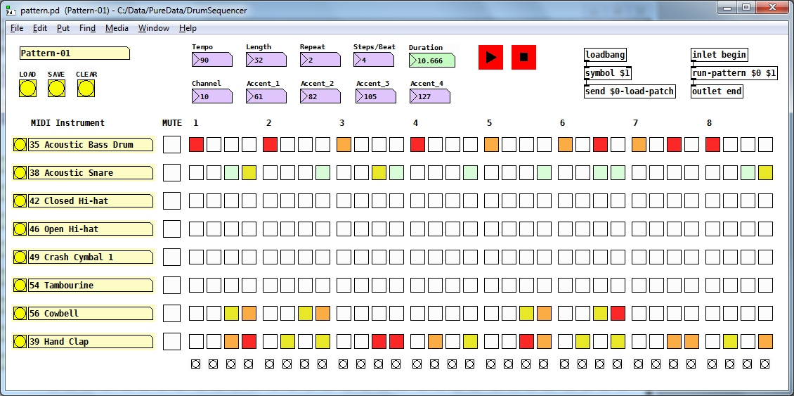
Although you can add or remove Pd objects in this window, it's recommended that you don't, unless you're fairly knowledgeable about editing Pure Data patches. You should be able to create, save, load and modify patterns without modifying the Pure Data code in this window.
To load a pattern, save a pattern (possibly under a different name) or clear the pattern, use the three buttons in the top left corner, labeled “LOAD”, “SAVE” and “CLEAR”. The file name of the currently-loaded pattern is display above these three buttons.

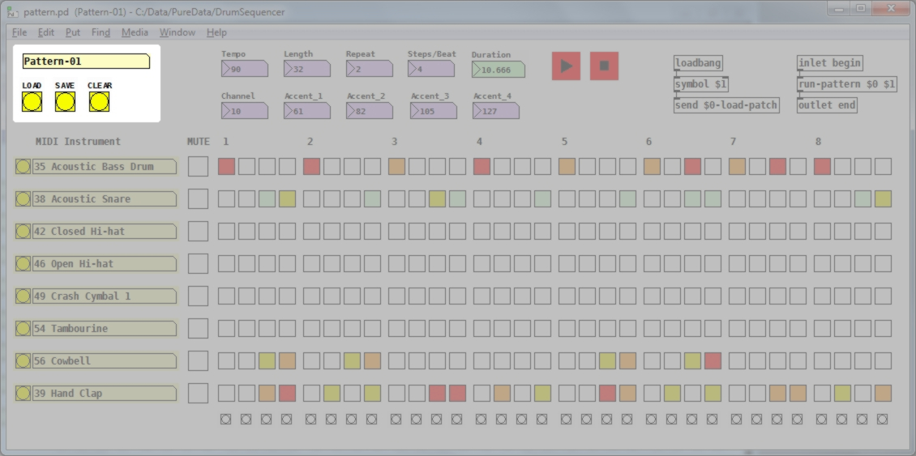
To the right of these buttons, there are number boxes in which you can enter the tempo (in BPM), the length of the pattern (the number of steps in the pattern, from 1 to 32), the number of times to repeat the pattern (from 1 up to some very large number), the number of steps per beat (from 1 to 32), the MIDI channel to send the output on (which defaults to 10, but can be from 1 to 16), and the four accent levels (this will be explained below). The total duration of the pattern, in seconds, will be automatically calculated and displayed in the green box labeled “Duration”.
Note that the actual MIDI device to send the output to is specified under “Media / MIDI Settings...” in the Pure Data menu bar. Your MIDI device must be connected before starting Pure Data (if it's a hardware drum machine) or already running (if it's a soft synth running on your computer).
The percussion instruments you want to use are selected by clicking on the yellow buttons on the left side of the window (see below). Each pattern can use up to 8 instruments, and these can be different for each pattern. So although there's a limit of 8 instruments for each pattern, if you want to use more that 8, you can create two or more patterns that run in parallel.

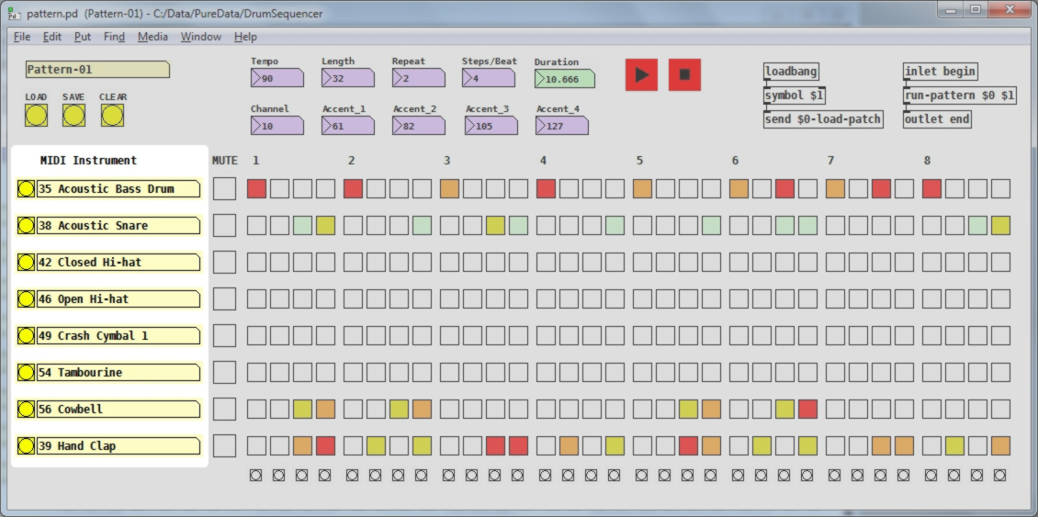
When you click on one of the yellow buttons, a drop-down list of standard MIDI percussion instruments will be displayed, from which you can select the instrument you wish to use. The list of instruments can be found in the file “Percussion.txt” in the sub-folder “data”. You can edit this file if you want to translate the names to another language, or just use names of your own choosing, but be careful to keep the file in the same format, with one instrument per line, preceded by the MIDI note number for that instrument. Here is the file if you ever need to recover the original contents:

81 Open Triangle
80 Mute Triangle
79 Open Cuica
78 Mute Cuica
77 Low Woodblock
76 High Woodblock
75 Claves
74 Long Guiro
73 Short Guiro
72 Long Whistle
71 Short Whistle
70 Maracas
69 Cabasa
68 Low Agogô
67 High Agogô
66 Low Timbale
65 High Timbale
64 Low Conga
63 Open High Conga
62 Mute High Conga
61 Low Bongo
60 High Bongo
59 Ride Cymbal 2
58 Vibra Slap
57 Crash Cymbal 2
56 Cowbell
55 Splash Cymbal
54 Tambourine
53 Ride Bell
52 Chinese Cymbal
51 Ride Cymbal 1
50 High Tom
49 Crash Cymbal 1
48 Hi-Mid Tom
47 Low-Mid Tom
46 Open Hi-hat
45 Low Tom
44 Pedal Hi-hat
43 High Floor Tom
42 Closed Hi-hat
41 Low Floor Tom
40 Electric Snare9 Hand Clap38 Acoustic Snare
37 Side Stick
36 Electric Bass Drum
35 Acoustic Bass Drum
00 Unassigned
Note that the MIDI note numbers should be in descending order if you want them to display in ascending order in the menu (they're loaded in reverse order).
Each instrument can be selectively muted by clicking on the box in the column labeled “MUTE”. The box will be changed to red if the instrument is currently muted; otherwise, it will be empty (white).

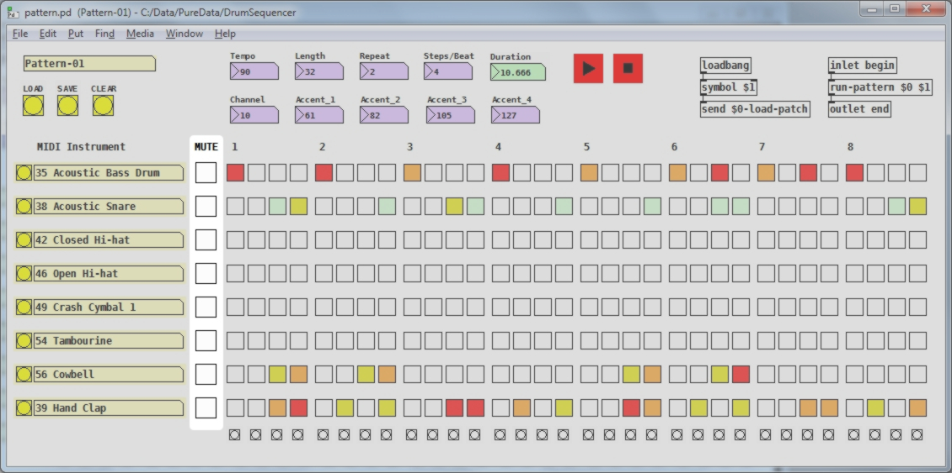

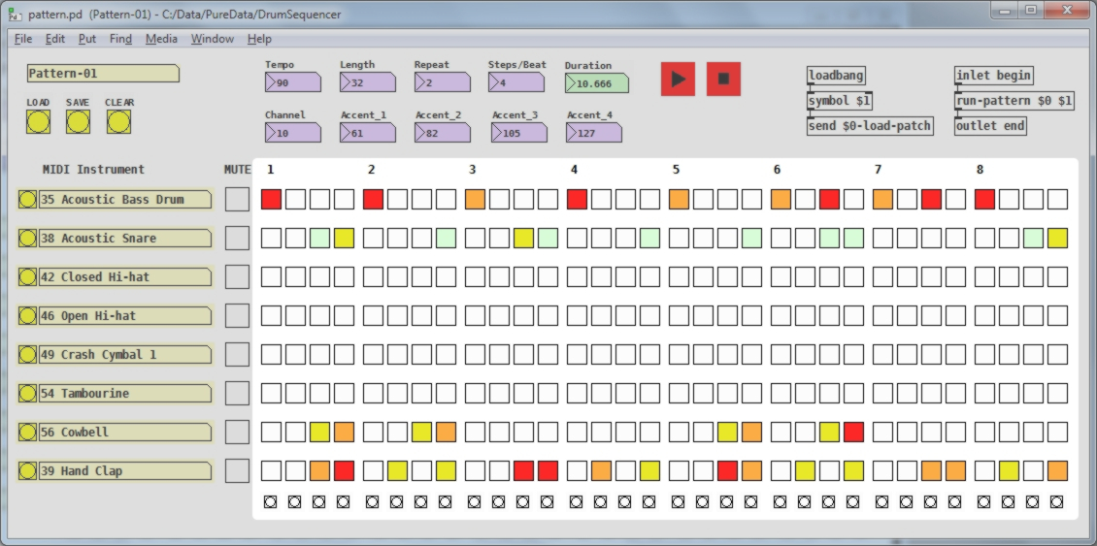
Finally (and most importantly), the patterns for each instrument are entered using the grid of squares to the right:
The amount of accent to apply to each hit can be set to one of four levels. To specify the four levels (in terms of MIDI note velocity), use the four boxes at the top of the window, mentioned previously, labeled “Accent 1”, “Accent 2”, “Accent 3” and “Accent 4”. They can be set to any value between 1 and 127 (the range of values used by MIDI to indicate “velocity”). They would normally increase in value, from left to right, but you can set them to any values you wish, within the range of 1 to 127.
The first time you click on one of the steps in the pattern, it will be set to level 1 and the colour will change to light green. If you click on it a second time, it will be set to level 2 and the colour will change to yellow. If you click on it a third time, it will be set to level 3 and the colour will change to orange. And if you click on it a fourth time, it will be set to level 4 and the colour will change to red. Finally, if you click on it a fifth time, it will be turned off and the colour will change back to white.
To run or stop the pattern, use the two red transport buttons at the top of the window (see below). As the pattern runs, the small “LED's” at the bottom of the window will flash on and off.
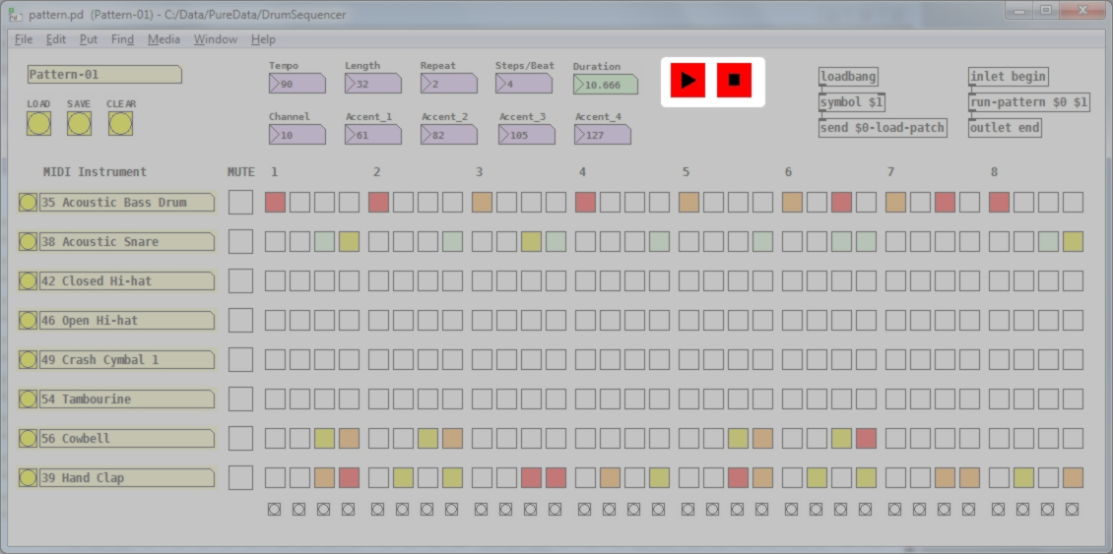

5. Getting Support

If you run into problems or have questions, please visit the project repository on Github:
https://github.com/dfkettle/MIDI-Drum-Sequencer

